DataFlux PPC Audit

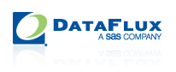

www.dataflux.com

24 March 2011

Prepared for Scott Batchelor,

Marketing Communications Director

DataFlux Corporation   
940 NW Cary Parkway, Suite 201   
Cary, NC 27513

By Steven Kent

Method Savvy

1. **Campaign Structure** - How the keywords, ad groups and campaigns are structured.

**Importance**: 8/10 - Having the correct account structure is important to running the account efficiently.

**DataFlux**: The campaigns are set up in a time-based manner (e.g. Q2 2010). This is not the most beneficial approach as campaigns have to be copied and repeated.

**DataFlux Score**: 2/5

**Recommendations**: Change to a theme, network, or geographic based campaign group structure. This will result in better control of spending, easier testing and experimentation.

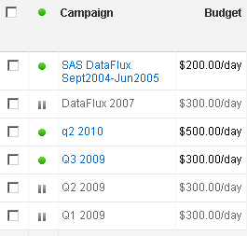

1. **Ad Groups** – The groupings of keywords into Ad Groups.

**Importance** 7/10 - It is important to have keywords divided into groups of a similar theme.

**DataFlux**: DataFlux ranks well on this factor as the keywords do appear to be organized into related terms and then put into Ad Groups.

**DataFlux Score**: 4/5

**Recommendations**: A good base to build off.

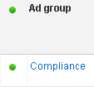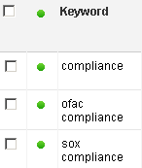

1. **Keyword Matching** – What type of matching (exact, phrase and broad) is being used?

**Importance** 7/10 – Selecting the wrong match type can push costs higher unnecessarily, as well as mean that clicks are irrelevant, or can result in a very low number of clicks.

**DataFlux**: There are some problems here: some keywords are using broad match for the same terms, and so are over-lapping. E.g. data governance and data goverence software are both broad match.

**DataFlux Score**: 2/5

**Recommendations**: Certain keywords need to be moved to exact match and phrase match to give better control.

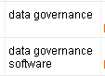

1. **Negative Keywords** – Keywords which should not appear in search phrases.

**Importance:** 5/10 - Having a smart negative keyword list can boost relevancy and keep out extraneous or irrelevant searches. Helps push up click-thru-rates.

**DataFlux**: Not currently using any negative keywords at an ad group or campaign level.

**DataFlux Score**: 0/5

**Recommendations**: Add some appropriate negative keywords.

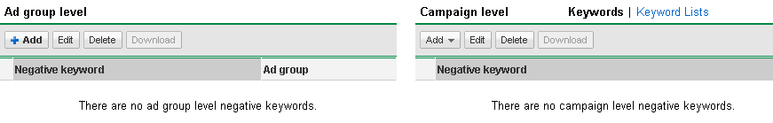

1. **Display Network** – Showing ads on the content network.

**Importance**: 9/10 – Deciding to use or not use the display network is a vital decision for an account. A well run account most often does use the display network in a smart way.

**DataFlux**: Not currently using the display network, but has been used previously.

**DataFlux Score**: 2/5

**Recommendations**: Account shows display network was used, with a lower cost per click than the search page. Worth investigating and running correctly.

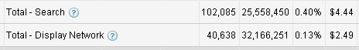

1. **Campaign Metrics** – Click-Thru-Rate.

**Importance**: 5/10 - The click thru rate play a big part in the cost equation, as well as the ad positioning. Matters less for display network.

**DataFlux**: Overall CTR of 0.25% (low) with highest Ad Group being 3% (acceptable) for DataFlux.

**DataFlux Score**: 3/5

**Recommendations**: Room for improvement in some ad groups. The ad groups with the highest number of clicks have CTRs of 0.78% and 0.29% respectively. Increasing the CTR is long-term process and produces a lower cost campaign.

1. **Campaign Metrics** – Average Ad Position.

**Importance**: 4/10 - Too high a position means over paying, too low means the ad is un-noticed on the page.

**DataFlux**: Overall search position of 2.8

**DataFlux score**: 4/5

**Recommendations**: At about position 3 is pretty good, and about where most accounts need to be. There might be some areas where it could be a little lower.

1. **Ads –** Overall.

Importance: 10/10 - The right number of ads, the text content, the variety and the page destination links are all key to a well-run campaign.

**DataFlux**: There are only three ads with a CTR over 1%. This could be improved. In terms of consistency of message, the text of the ads is linked to the ad groups, which is good. Not ad groups have more than two ads, and a number of them have only one ad.

**DataFlux Score**: 2/5

**Recommendations**: Ads are important, and DataFlux needs to have more ads running in order to test and improve within each ad group.

1. **Ads -** Content.

**Importance**: 8/10 - The right content is a big part of enticing users to click

**DataFlux**: The ad text is factual, and generally lacks a call to action beyond ‘ learn more’ or an incentive to click.

**DataFlux Score**: 3/5

**Recommendations**: Add more variety in ad content, consider offering incentives like white papers, and make more calls to action.

1. **Ads -**  Links.

**Importance**: 8/10 - Sending users to the homepage is often a mistake. There needs to be a strong link between the individual ad text and the page.

**DataFlux**: Ads are going to pages relevant to the particular ad group.

**DataFlux Score**: 5/5

**Recommendations**: Keep going with sending traffic to pages other than the homepage. Perhaps add some clearer calls to action on these pages.

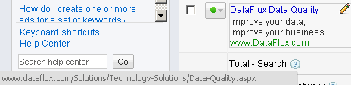

1. **Ad Scheduling** – Controls when ads are shown based on time.

**Importance**: 4/10 – Can help boost CTRs and be shown

**DataFlux**: Currently running from 8am to 5pm East Coast time.

**DataFlux Score**: 3/5

**Recommendations**: Missing out on afternoon showings on the West Coast. Should adjust to a later time as time-zones are not taken into account.

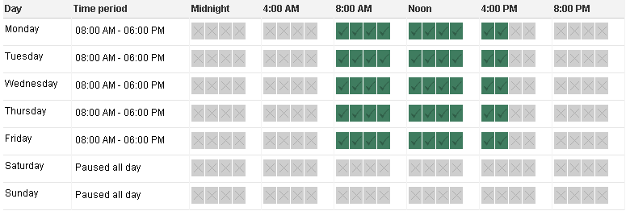

1. **Keyword Bidding** – Keyword bidding strategy can make a difference to prices.

**Importance**: 9/10 – Bidding too high means over paying for keyword clicks

**DataFlux**: Max CPC defaults are set high at $10 and are uniform.

**DataFlux Score**: 3/5

**Recommendations**: Reduce the default bid, and have bids tied to each indiviaual ad grou, rather than uniform across the campaigns. This will help reduce costs and take advantage of the different prices and levels of competition which each keyword faces.

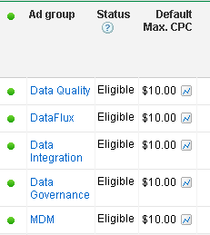

1. **Keyword choice** – Number of keywords, and relevance.

**Importance**: 8/10 - Having the right number of relevant keywords matters

**DataFlux**: Historically the account has 856 keywords.

**DataFlux Score**: 2/5

**Recommendations**: There a large number of keywords which are rarely shown due to the low quality score. These either need to be linked to destination pages with more relevant content, or the bid needs to be increased.

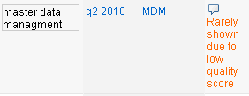

1. **Conversion Tracking** – A snippet of code in the site which registers conversion.

**Importance**: 9/10 – Vital for keeping track of goals

**DataFlux**: Looks like there used to be conversion goals in place, but there are not any over the past year.

**DataFlux Score**: 2/5

**Recommendations**: Select and install conversion tags for goals on the site. These could be linked to Calls-To-Action or incentives.



1. **Retargeting** – Display Ads can be targeted to appear on other websites after the user has left the site.

**Importance**: 3/10 – Can be useful to keep prospects engaged.

**DataFlux**: None running

**DataFlux Score**: 1/5

**Recommendations**: Add some retargeting audiences to selected groups.

1. **Overall**

The DataFlux account is achieved a high number of clicks , but could be made more efficient by slowly improving the click-thru-rate, while increasing the quality of the ads. This should bring down costs, while increasing the reach of the campaigns. The account needs to be restructured, keywords revised and rebuilt and the ads revised and extended.

Overall, a number of other measures can be taken to improve the campaign and produce results for the DataFlux site.

*By Steven Kent*

*Steven has over five years web marketing and pay-per-click experience. He is Google Adwords Certified, and has run hundreds of thousands of dollars in campaigns for more than twenty clients. He can be contacted at* [*spkent@gmail.com*](mailto:spkent@gmail.com)